

ugv PROJECT REPORT

MUNYAKABERA JEAN CLAUDE 2019040146006

MUNYAKABERA JEAN CLAUDE 2019040146006

MUNYAKABERA JEAN CLAUDE 2019040146006



December 17, 2021

UESTC

MBZIRC

# INTRODUCTION

## THE UGV

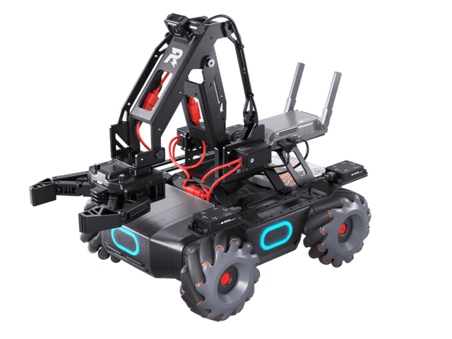The unmanned ground vehicle used was the DJI ROBOMASTER EP, it has multiple sensors like an infrared depth sensor, various hit sensors on the side and a 5 megapixels camera sensor that outputs at a maximum of 2560 by 1440 pixels.

The arm and claw can stretch to a length of 10 cm it is composed of 3 servo motors and a number linkages that enables the claw to stay straight while the arm is moving.

## THE TASK

# IMPLEMENTATION

## COMPUTER VISION

## FORWARD & INVERSE KINEMATICS

## INFERING DEPTH & HEIGHT OF OBJECTS

# RESULTS, LIMITATIONS & FUTURE WORK

# CONCLUSION